LAB 2 TUTORIAL

This tutorial covers:
Chapter 1- Introduction to Programming
Chapter 2- Introduction to C++
Chapter 3- Expressions and Interactivity

- Basic Multiple Choice and Subjective Question

- These are data items whose values do not change while the program is running.
a. Literals b. variables c. comments d. integers

- A character literal is enclosed in ________ quotation marks, whereas a string literal is enclosed in ________ quotation marks.

a. double, single
b. triple, double
c. open, closed
d. single, double

- State the following statements whether it is True or False.

No | Statements | True/False
a. | An identifier can be any sequence of digits and letters. | False
b. | In C++, there is no difference between a reserved word and a pre-defined identifier. | False
c. | A C++ identifier can start with a digit. | False
d. | The operands of the modulus operator must be integers. | True
e. | If a = 4; and b = 3; then after the statement a = b; the value of b is still 3. | True
f. | In the statement cin >> y;, y can only be an int or a double variable. | False
g. | The following code is a legal C++ program.  int main ()  {  return 0;  } | True
h. | Suppose x = 5. After the statement y = x++; execute, y is 5 and x is 6. | True
j. | Suppose a = 5. After the statement ++a; executes, the value of a is still 5 because the value of the expression is not saved in another variable | False

Prefix and Postfix

When you use the prefix form, as in ++number, you place the operator in front of the name of the variable. This increment or decrements the value immediately.

When you use the postfix form, as in number++, you place the operator after the name of the variable. This increment or decrements the value after it is used.

The example that follows illustrates the use of both forms of the increment operator in C++:

x = 5;
y = x++; // Postfix form
// y is assigned the value of x,
// then x is incremented.
// Value of y is 5.
// Value of x is 6.

- What is the output of the following statement? Given that all the variable value are integer.
cout << 4 * (15 / (1 + 3)) << endl;

a. 15
b. 12
c. 63
d. 72

- What is the value of cookies after the execution of the following statements?

int number = 38, children = 4, cookies;
cookies = number % children;

a. 2 b. 0 c. 9 d. 5

- Which of the following correctly consolidates the following declaration statements into one statement?

int x = 7;
int y = 16;
int z = 28;

a. int x = 7; y = 16; z = 28;
b. int x = 7 y = 16 z = 28;
c. int x, y, z = 7, 16, 28
d. int x = 7, y = 16, z = 28;

- What will the following code display?

cout << "Monday";
cout << "Tuesday";
cout << "Wednesday";

a. Monday
Tuesday
Wednesday

b. Monday Tuesday Wednesday

c. MondayTuesdayWednesday

d. "Monday"
"Tuesday"
"Wednesday"

- You must have a ________ for every variable you intend to use in a program.
a. purpose
b. definition
c. comment
d. constant

- Look at the following program and answer the question that follows it.

1 // This program displays my gross wages.
2 I worked 40 hours and I make $20.00 per hour.
3 #include <iostream>
4 using namespace std;
5
6 int main()
7 {
8 int hours;
9 double payrate;
10
11 hours = 40;
12 payRate = 20.0;
13 grossPay = hours + payRate;
14 cout << "My gross pay is $ << grossPay << endl;
- return 0;

- Which line(s) in this program cause output to be displayed on the screen?
14

- Detect the type of error and correct the code with the correct syntax.

Type of Error | Correction
Syntax Error:  Comment don’t have a proper syntax “//”  No closing bracket for main() }  No declaration of grossPay  Missing of “” in line 14  Declaration of payrate vs payRate  Logic Error:  The formula of grossPay is wrong it would give a wrong output | // I worked 40 hours and I make $20.00 per hour  Int main(){  int hours;  double payrate;  double grossPay;  cout << "My gross pay is $” << grossPay << endl;  }  grossPay = hours * payRate;  }

- Assume that a program has the following string object definition:

string name;

Which of the following statements correctly assigns a string literal to the string object?
A) name = Jane;
B) name = "Jane";
C) name = 'Jane';
D) name = (Jane);

- Write each of the following statement as a C++ expression:

No | Statement | C++ expression
a. | 32 times a plus b | 32 * a+ b
b. | The character that represents 8 | ‘8’
c. | The string that represents the name Mariah Carey | “Mariah Carey”
d. | (b² – 4ac) / 2a | (b * b – 4 * a * c) / (2 * a)

- Write C++ statements to do the following:

No | Statement | C++ statements/syntax
a. | Declare int variable as num1 and num2 | int num1;  int num2;
b. | Prompt the user to input two numbers. | cout << “Enter two numbers separated by spaces.” <<endl;
c. | Input the first number in num1 and the second number in num2. | cin >> num1 >> num2;
d. | Output num1, num2, and 2 times num1 minus num2. Your output must identify each number and the expression | cout << “num1 = “ << num1 << “num2 = “ << num2 << “2 * num1 – num2 = “ << 2 * num1 – num2 << endl;
e. | header file that must be included to use the function setpricision | <iomanip>
f. | header file that must be included to use the function sqrt | <cmath>

- 8. x = 2 * x is also equal to x *=2. Write the equivalent statements to the statements below:
a. x = x + y – 2;
b. z = z * x + 2 * z;
c. y = y / (x + 5);
x += y – 2;
z *= x + 2;
y /= x + 5;

- Suppose name is a string variable. What are the values of the full name after the following input statements executed? Given the input is: Lance Grant
cin >> name; Lance
getline (cin, name); Lance Grant

- Suppose that x, y, and z are int variables, and x = 10, y = 15, and z = 20. Determine whether the following expressions evaluate to true or false.
a. ! (x > 10)
b. x < = 5 || y < 15
c. (x != 5) && (y != z)
d. x >= z || (x + y >= z)
True, because x is 10 not bigger than that
False, because both conditions are false revise back AND operator
True, because both condition true
True, because it is OR operator, if only one is true then it will be true. For this question, both are true.

- You want the user to enter the length, width, and height from the keyboard. Which cin statement is correctly written?
- cin << length, width, height;
- cin.get(length, width, height);
- cin >> length >> width >> height;
- cin >> length, width, height;
- cin << length; width; height;

- In the following C++ statement, what will be executed first according to the order of precedence?

result = 6 - 3 * 2 + 7 - 10 / 2 ;

- 6 - 3
- 3 * 2
- 2 + 7
- 7 - 10
- 10 / 2

10/2 and 3*2 have the same precedence but * have the higher associativity than / (left to right)

Remember order of precedence?

- What will the value of x be after the following statements execute?

int x = 0;
int y = 5;
int z = 4;

x = y + z * 2;

- 13
- 18
- 0

- Application Questions (Chapter 1- chapter 3)

- Write a pseudocode and c++ program that reads two numbers and multiplies them together and print out their product.

Pseudocode:

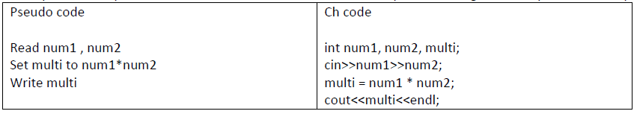

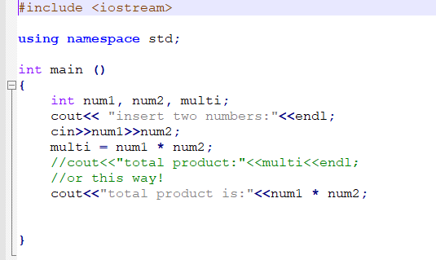

- Write a pseudocode and c++ program that tells a user that the number they entered is not a 5 or a 6. Use the correct operator to solve the problems.

There are many ways to answer this type of questions! p/s CH code is C++ Code

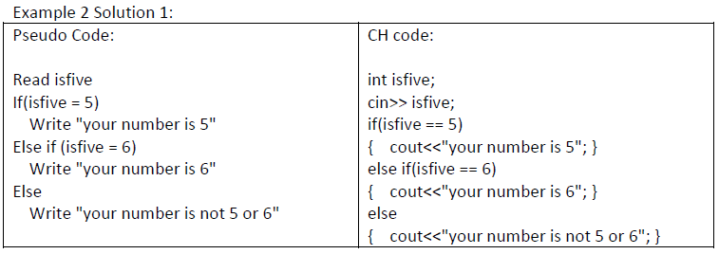
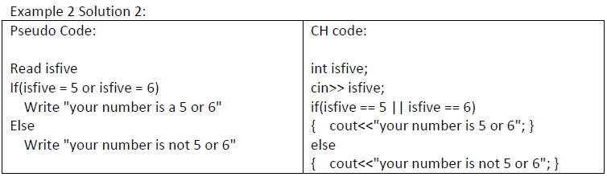

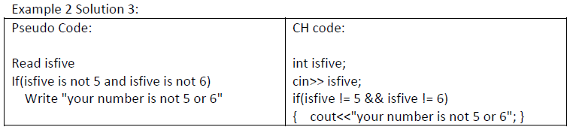

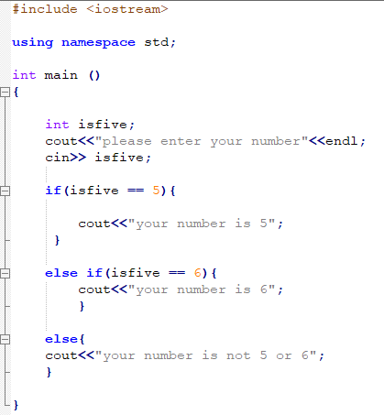

- Write a complete c++ program to compute BMI index of a person. The program will accept input from the user. Use built-in class from other header (i.e. <cmath>) in the formula/ process and set the precision to 2 decimal places.

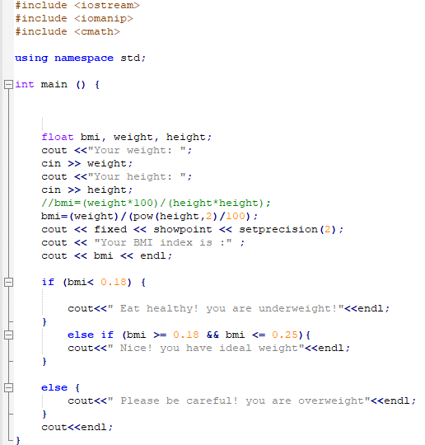

- Write a complete c++ program to calculate pay. If the hours are greater than 40, then the pay is calculated overtime, or else the pay is calculated in the usual way (rate * hours). Use a formula to calculate the pay for overtime.

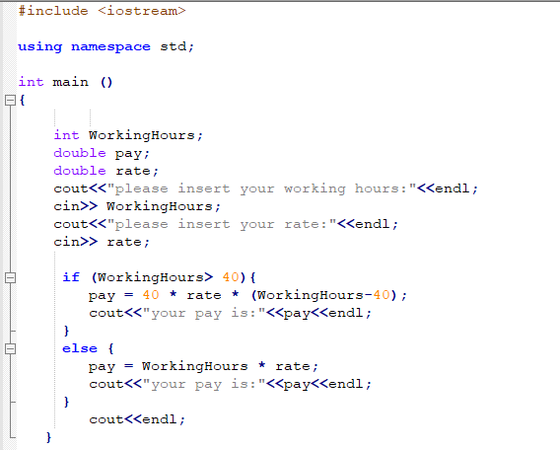

- Write c++ program to ask a user to enter a number. If the number is between 0 and 10, write the word blue. If the number is between 10 and 20, write the word red. if the number is between 20 and 30, write the word green. If it is any other number, write that it is not a correct color option.

